Rossmoyne SHS

Trial WACE Examination, 2010

Question/Answer Booklet

MATHEMATICS 3A/3B
SOLUTIONS

Section Two:

Calculator-assumed

Student Number: In figures

In words

Your name

Time allowed for this section
Reading time before commencing work: 10 minutes
Working time for paper: 100 minutes

Material required/recommended for this section

To be provided by the supervisor
This Question/Answer booklet
Formula sheet (retained from Section One)

To be provided by the candidate
Standard items: pens, pencils, pencil sharpener, eraser, correction fluid, ruler, highlighters

Special items: drawing instruments, templates, notes on two unfolded sheets of A4 paper, and up to three calculators satisfying the conditions set by the Curriculum Council for this course.

Important note to candidates

No other items may be used in this section of the examination. It is your responsibility to ensure that you do not have any unauthorised notes or other items of a non-personal nature in the examination room. If you have any unauthorised material with you, hand it to the supervisor before reading any further.

Structure of this paper

Section | Number of questions available | Number of questions to be answered | Working time (minutes) | Marks available
Section One:  Calculator-free | 7 | 7 | 50 | 40
Section Two:  Calculator-assumed | 12 | 12 | 100 | 80
 |  |  |  | 120

Instructions to candidates

- The rules for the conduct of Western Australian external examinations are detailed in the Year 12 Information Handbook 2010. Sitting this examination implies that you agree to abide by these rules.

- Write your answers in the spaces provided in this Question/Answer Booklet. Spare pages are included at the end of this booklet. They can be used for planning your responses and/or as additional space if required to continue an answer.
- Planning: If you use the spare pages for planning, indicate this clearly at the top of the page.
- Continuing an answer: If you need to use the space to continue an answer, indicate in the original answer space where the answer is continued, i.e. give the page number. Fill in the number of the question(s) that you are continuing to answer at the top of the page.

- Show all your working clearly. Your working should be in sufficient detail to allow your answers to be checked readily and for marks to be awarded for reasoning. Incorrect answers given without supporting reasoning cannot be allocated any marks. For any question or part question worth more than two marks, valid working or justification is required to receive full marks. If you repeat an answer to any question, ensure that you cancel the answer you do not wish to have marked.

- It is recommended that you do not use pencil except in diagrams.

Section Two: Calculator-assumed (80 Marks)
This section has twelve (12) questions. Answer all questions. Write your answers in the space provided.

Working time for this section is 100 minutes.

Question 8 (5 marks)
In researching the different modes of transport that students used to travel to and from a particular school, the principal decided to ask a sample of 50 out of the 860 students enrolled.

(a) Briefly describe one advantage and one disadvantage of using a sample rather than a census for this research. (2 marks)
Advantages: Quicker, cheaper, easier to administer, etc.

Disadvantages: May pick a biased sample which is not representative of whole population.

1 mark each (advantage/disadvantage)

Parts (a) and (b) well done

(b) The principal decided to use a stratified sample to reflect the school population consisting of 325 primary, 312 middle-school and 223 upper-school students. State how many upper-school students would form part of this sample and name a suitable method to choose them.
(2 marks)
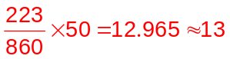students. 1 mark

Choose these students using either random or systematic sampling.
1 mark

(c) If 8 students in the sample answered 'yes' to using bicycles, estimate, to the nearest ten, how many students in the school are likely to use bicycles. (1 mark)
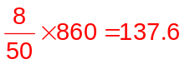 Hence estimate 140 students use bicycles.
1 mark

Too many students lost the mark for part (c)
Question 9 (6 marks)
A project involves 8 tasks, each of which requires the uninterrupted labour of one person for the time shown in this table.

Task | A | B | C | D | E | F | G | H
Time required (minutes) | 7 | 12 | 18 | 15 | 11 | 10 | 9 | 2

Some of the tasks cannot begin until other tasks are complete, as described below:
- Tasks D and E cannot begin until A is complete.
- Tasks F and G cannot begin until B is complete.
- Task H cannot begin until tasks E and F are both complete.

(a) Construct a project network to show the above information. (3 marks)

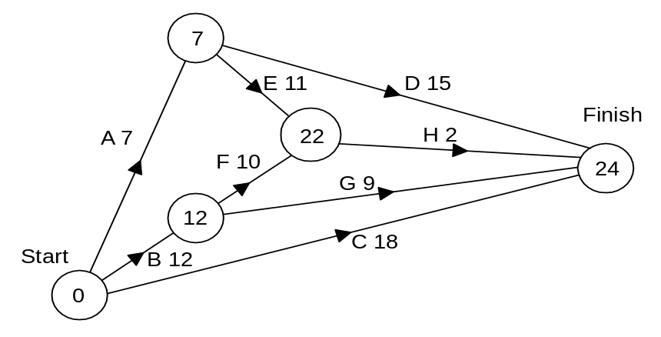
lose 1 mark each error/omission
(b) Find the minimum completion time for the project and state the critical path. (1 mark)
Min Comp Time is 24 minutes.

Critical path is B - F - H.
1 mark, f.t.

(c) How many people would be required to complete the project in the time stated in your answer to part (b)? (1 mark)
5 people.
1 mark

(d) If the times for tasks E and G were both increased by 5 minutes, what effect would this have on the minimum completion time found in part (b)? (1 mark)
Increase the MCT by 2 minutes to 26 minutes.
1 mark

Only part (c) caused any problems
Question 10 (5 marks)
The table below displays the cost of the quarterly electricity and gas consumption for a sample of 14 households in an apartment block, rounded to the nearest dollar.

Household | Electricity ($) | Gas($)
1 | 151 | 110
2 | 149 | 107
3 | 135 | 97
4 | 144 | 104
5 | 137 | 98
6 | 138 | 102
7 | 150 | 112
8 | 142 | 116
9 | 168 | 123
10 | 167 | 121
11 | 161 | 121
12 | 155 | 111
13 | 160 | 119
14 | 154 | 114

(a) Describe the relationship between the cost of electricity and gas consumption for this sample of households. (1 mark)
(1)Strong, linear relationship.
(2) Generally, an increase in the cost of electricity is associated with an increase in the consumption of gas
pay either answer 1 mark

(b) Removal of the data for one of the households from the table significantly increases the strength of the linear correlation between the variables. State which household should be removed and justify your answer. (2 marks)
The point for Household 8 is a long way from the regression line and should be removed. Removal of this household increases the strength of the correlation coefficient between x and y from 0.8998 to 0.9792.
1 mark for point, 1 mark for reason

Answer the remaining questions with the household identified in part (b) removed from the table.

(c) Determine the equation of the linear regression line for on . (1 mark)
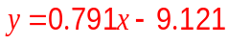
1 mark

(d) Calculate the expected quarterly cost of gas for a household with an electricity bill of $158.
(1 mark)
0.791(158)-9.121=115.857

Expect a bill close to $116. 1 mark

This question fairly well done
Question 11 (6 marks)
The volume of water in a storage tank changes with time as shown in the graph below. The volume is in kilolitres and the time is in hours from noon.
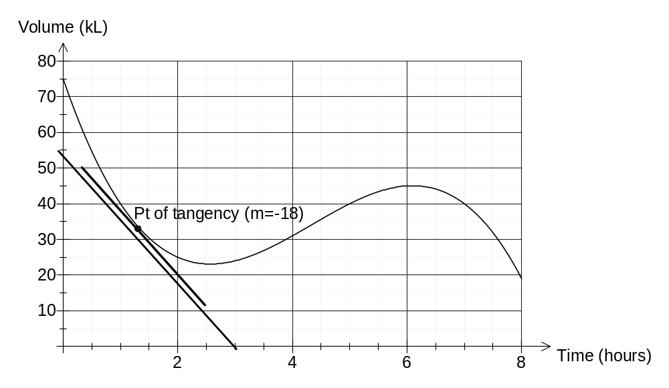

Use the graph to estimate:

(a) the volume of water in the tank after seven and a half hours. (1 mark)
32 kL
1 mark

Well done
(b) the average rate of change of volume from the fourth to seventh hour. (2 marks)
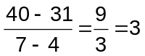kL/hour
1 mark 1 mark

Some people forgot to divide by 3 to find average

(c) the earliest time at which the instantaneous rate of decrease of volume of water is 5 litres per second [Hint: - convert 5 litres per second to an amount per hour]. (3 marks)
Few could find a point where the gradient was -18
Convert 5 L/second to kL/hour: 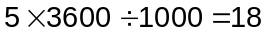kL/h 1 mark
Draw tangent to curve with gradient of -18 (-ve as rate of decrease).
Earliest time, so around t=2. Use (3, 0) and (54, 0) or similar for slope. 1 mark
Point of tangency approximately when t=1 hours.(accept 1hours) 1 mark

Question 12 (7 marks)
In the process of developing a new plastic injection moulding machine, an engineering company measured the lengths of 150 pipes it produced.

The lengths, to the nearest centimetre, are summarised in the table at right:

Length of pipe (cm) | Number of pipes
88 - 92 | 3
93 - 97 | 6
98 - 102 | 27
103 - 107 | 34
108 - 112 | 44
113 - 117 | 27
118 - 122 | 8
123 -127 | 1

(a) Draw a histogram for these data. (2 marks)
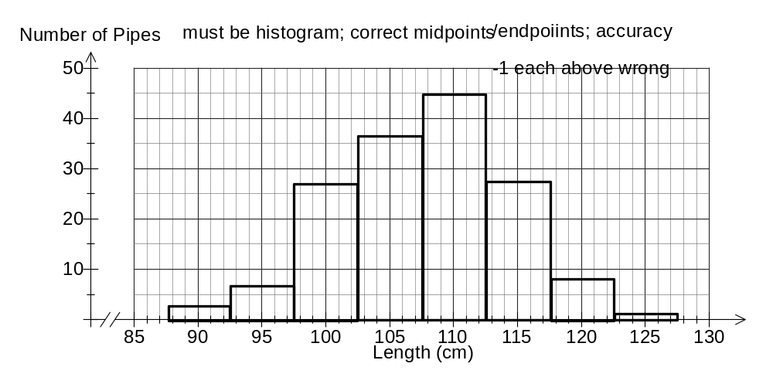
The columns must be joined!!
(b) The company engineers thought that the pipe lengths followed a normal distribution. How does the histogram support this conjecture? (1 mark)
The overall bell-shape of the histogram, with frequencies peaking in the middle and tailing off towards the extremes.
1 mark

Well done
(c) Assuming that the pipe lengths follow a normal distribution with the same mean and standard deviation as the sample above, if the machine produced 6000 pipes, how many of them would be expected to have a length of more than 127.5cm? (4 marks)
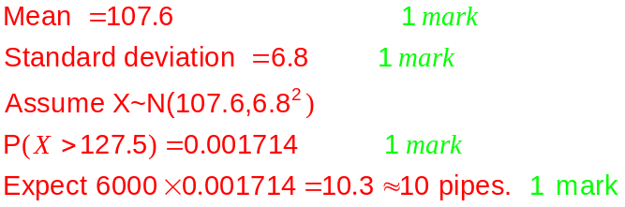

Most got the first 2 marks; few got the last 2 marks
Question 13 (8 marks)
The number of new accounts () opened each quarter at a local branch of a bank for the period 2002 - 2006 have been graphed below, where 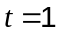 is the first quarter of the year 2002. The regression line, 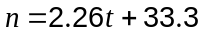, for the four point centered moving averages is also shown.

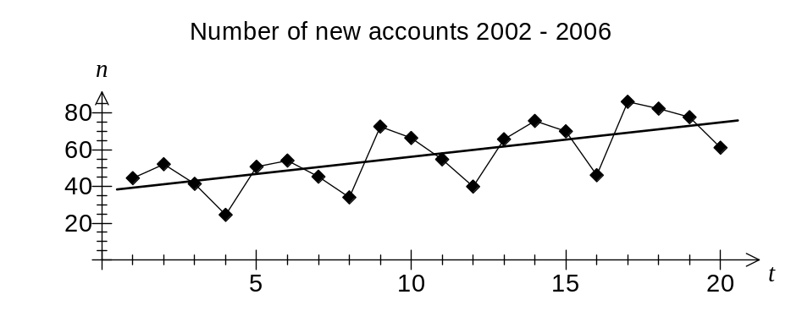

Some of the data for the years 2005 and 2006 is shown in the table below, together with associated four point centred moving averages and residuals. The residuals for the first quarters of 2003 and 2004 were 7.75 and 17.25.

 |  | 4pt CMA | Residual
13 | 66 | 61.125 | 4.875
14 | A | 63.75 | 12.25
15 | 70 | 67 | 3
16 | 46 | 70.25 | -24.25
17 | 86 | 72 | 14
18 | 82 | 74.875 | 7.125
19 | 78
20 | B

(a) Describe a common trend of the data within each year. (1 mark)
Number of new accounts falls in third and fourth quarters.
1 mark

(b) Explain the purpose of calculating four point centred moving averages for these data.
(1 mark)
To smooth out the annual trends and reveal the underlying increasing trend.
1 mark

Parts (a) and (b) well done
(c) Calculate the values of A and B in the table. (3 marks)

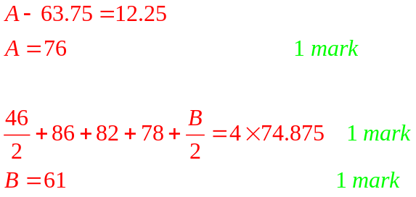

Most found A; many struggled with B

(d) Calculate the seasonal component for the number of new accounts in the first quarter.
Some students used only two residuals??? (1 mark)
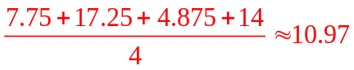
1 mark

(e) Use the moving average model to predict the number of new accounts opened in the first quarter of 2007. (2 marks)
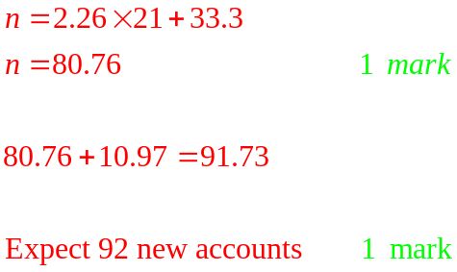

Some students forgot to add on the seasonal component they found in part (d)!!!
Question 14 (8 marks)
A student takes out a bank loan of $1450 to buy a laptop computer for use at university. One month after the loan began, interest of 1.3% is added to the balance of the loan and then the student makes a repayment of $75. This process is then repeated at monthly intervals until the loan is repaid.

(a) The recursive formula 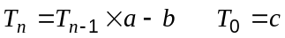 can be used to find the loan balance 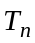 after repayments. State the values of , and . (2 marks)
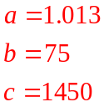
3 correct = 2 marks
1 or 2 correct = 1 mark

Most students found b and c; many couldn’t find a
(b) What is the balance of the loan just after the student has made the 12th repayment?
(1 mark)
$725.87
1 mark

It appeared many students didn’t see the hint in the question “recursive formula”

(c) The final repayment is less than the regular repayment of $75 so that after it is made the balance of the loan is nil. How much is the final repayment? (1 mark)
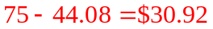
1 mark

Again, it appeared many students didn’t use the recursive function on their calculators!!

(d) Calculate the total interest charged by the bank over the life of this loan. (2 marks)
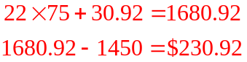
1 mark
1 mark

(e) If the rate of interest charged by the bank doubled, will your answer to part (d) also double? Justify your answer. (2 marks)
No. More of the $75 repayment will be needed to meet the interest charge and so the balance will reduce at a slower rate, therefore increasing the time of the loan and hence the total interest.

Yes = 0 marks
1 mark for NO, 1 mark for reason
Question 15 (11 marks)
Each week a carpenter needs a minimum of 600 nails, 200 screws and 120 bolts. The carpenter's local hardware store sells two different fastener packs. The Midi pack costs $4.50 and contains 10 nails, 20 screws and 4 bolts, whilst a Maxi pack costs $5.50 and contains 50 nails, 5 screws and 5 bolts.

Let be the number of Midi packs and be the number of Maxi packs bought each week.
(a) State three constraints concerning the number of packs that the carpenter must buy to meet his weekly needs, other than 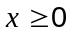 and 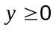. (3 marks)
# N S B cost
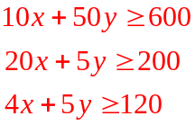
Midi x 10 20 4 4.50
Maxi y 50 5 5 5.50
Total ≥600 ≥200 ≥120
Nearly every student who set up the table above
1 mark each got the correct inequalities
Some students failed to indicate the feasible region in part (b) below:
(b) Graph the above inequalities on the axes below and indicate the feasible region. (3 marks)
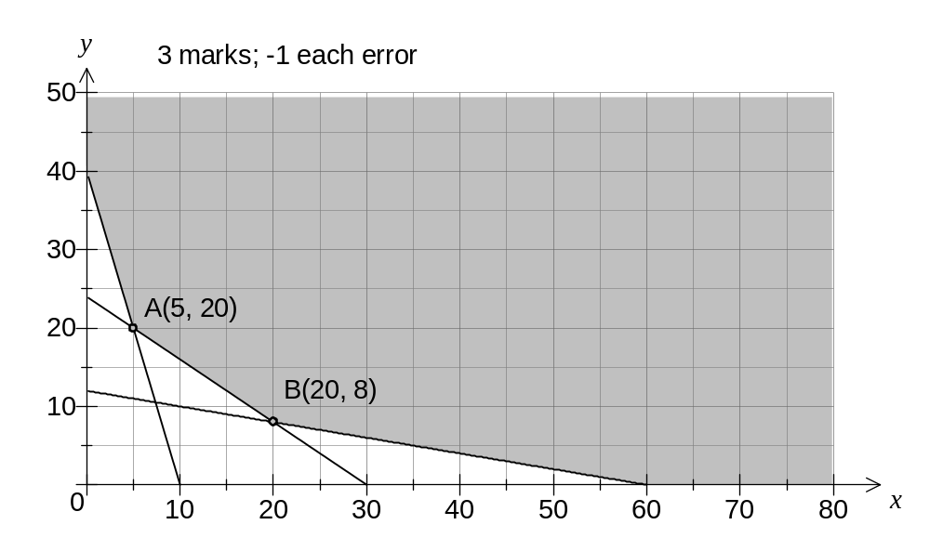
(c) How many of each type of pack should the carpenter buy to minimise weekly costs and what is the minimum cost? Justify your answer. (3 marks)
Cost 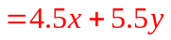
A(5, 20) has cost of $132.50
B(20, 8) has cost of $134.00 2 marks to here
1 mark for answer
Minimum cost is $132.50, buying 5 Midi packs and 20 Maxi packs.

Well done
(d) If the carpenter buys packs according to the optimal solution in (c), there will be an excess over the minimum weekly requirements for one of nails, screws or bolts. Which type of fastener has an excess, and by how large is this excess? (2 marks)
The line 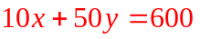 does not pass through A, and was derived from nails. So there is an excess of 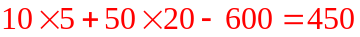nails.

2 marks (pay answer only, or give 1 mark for good reasoning)
Poorly done
Question 16 (7 marks)
Rectangle ABCD is enclosed within another rectangle PQRS so that the sides AB and PQ are parallel and 2cm apart. The vertical distance between sides CD and RS is 3cm and the horizontal distances between sides BC and QR and sides AD and PS are both 4cm.
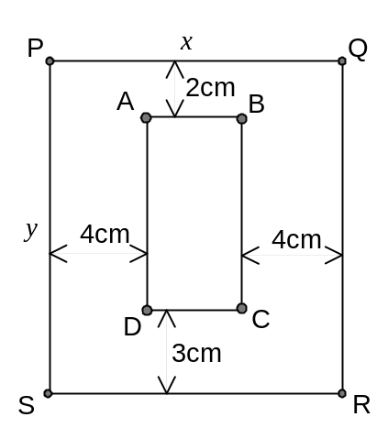
Let PQ and PS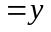. The perimeter of PQRS is 120 cm.

(a) Explain why 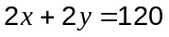. (1 mark)
Perimeter of PQRS is .
1 mark

(b) Show that the area of rectangle ABCD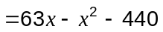. (3 marks)
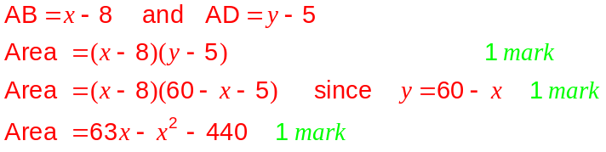

(c) Use differentiation to find the maximum possible area of ABCD. (3 marks)
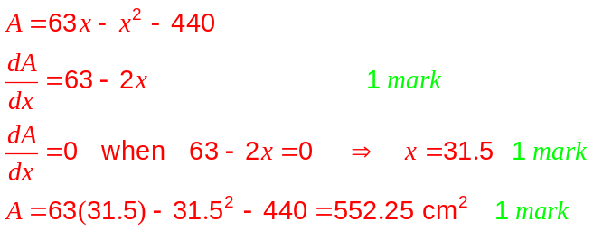

Parts (a) and (c) well done; most could not do (b)
Many students failed to realise they could use part (b) to do part (c)
Question 17 (6 marks)
(a) Calculate the smallest possible length of AB in the triangle shown below. (3 marks)
(The triangle is not drawn to scale).
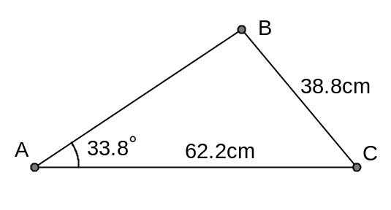
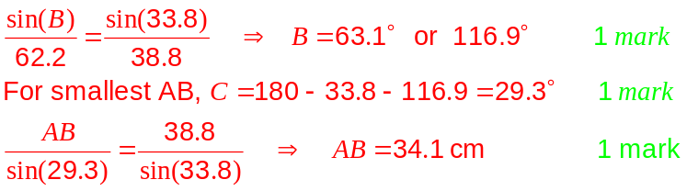

OR , using Solve mode
solve(38.8² = x² +62.2² – 2(x)(62.2)(cos33.8))

Few students picked up the keyword (SMALLEST) and only found one possibility (the largest)

(b) In the diagram below (not to scale), the line AC intersects the line BD at O. The angle AOB = 35°, and the lengths OB = 14cm, OD = 26cm and AC = 30cm. If the area of triangle ODC is twice that of triangle OAB, determine the length OA. (3 marks)
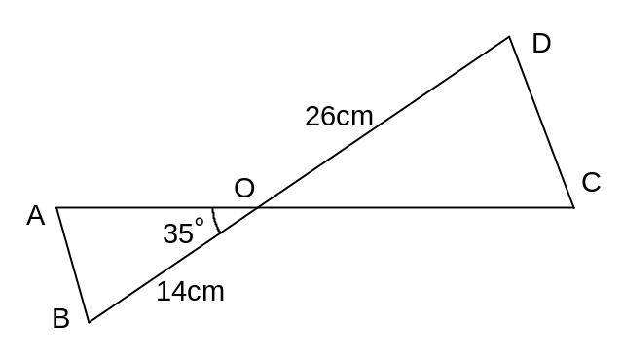

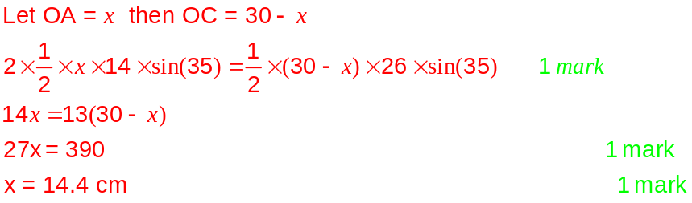

Many students had OC = 30 cm instead of AC
Question 18 (5 marks)
(a) After noticing that 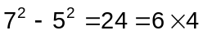 and that 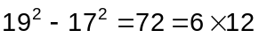, a student made the conjecture that the difference of the squares of any two consecutive odd integers is always a multiple of 6. Is this conjecture true? (2 marks)

No, it is false.

Consider the following counter-example:

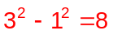

8 is not a multiple of 6.
1 mark for false; 1 mark for example

A number of students tried to PROVE this – all they had to do is state whether or not it is true, giving examples or a counter example

(b) Use algebra to prove that the difference of the squares of any two consecutive odd integers is always even. (3 marks)

Let the two odd numbers be 2n+1 and 2n+3.

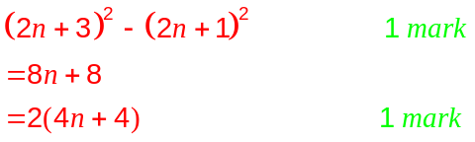

Hence the difference has a factor of 2 and so is always even.
1 mark

Many students could not expand either (2n + 1)2 or (2n + 3)2
Question 19 (6 marks)
(a) The function 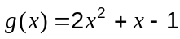 has a turning point when 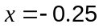. Write down the equation of the tangent to 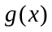 one unit to the right of the turning point, where 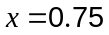.
(1 mark)
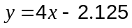

(b) Consider other quadratic functions of the form 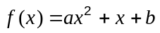 which have a turning point at 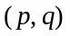.

(i) Determine an expression for in terms of . (2 marks)
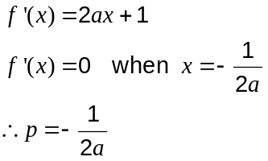
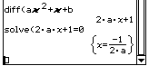

(ii) Find an expression for the equation of the tangent line to  at the point 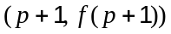 in terms of and , stating its gradient and y-intercept in simplest form. (3 marks)
Find tangent where 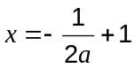

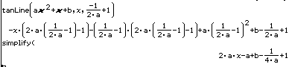

2 marks to here
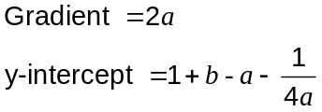
Parts (a) and (c) were direct use of the tanline function and should have caused no problems.
In part (b), few students used the fact that the gradient function (the derivative) is zero at a turning point. Students can still get the 3 marks for part (c) even if their answer to part (b) is wrong.
Additional working space

Question number(s):

